Subject:- LP3 (DAA)
Practical 1
Title :- Write a program non-recursive and recursive program to calculate Fibonacci numbers and analyze their time and space complexity.
Objective:
To implement and compare recursive and non-recursive (iterative) approaches for generating Fibonacci numbers, and to analyze their time and space complexities. The objective is to understand how recursion increases computational cost due to repeated subproblems and how iteration provides an optimized solution.

Theory:
The Fibonacci series is a sequence of numbers where each number is the sum of the two preceding ones. It begins with 0 and 1.
Mathematical Formula:
[ F(n) = F(n-1) + F(n-2) ]
with base cases:
[ F(0) = 0, \quad F(1) = 1 ]
Example: 0, 1, 1, 2, 3, 5, 8, 13, 21, 34 …
The Fibonacci sequence is widely used in mathematics, algorithms, dynamic programming, and computer science for analyzing recursive relationships and performance.
There are two major methods to compute Fibonacci numbers:
- Recursive Method: Function calls itself repeatedly for smaller subproblems until base conditions are met.
- Iterative Method: Uses loops to build the sequence without function calls.

Algorithm Steps Explanation:
🔹 1️⃣ Iterative Approach (Non-Recursive):
- Input number of terms n.
- Initialize first two terms 0 and 1.
- Use a for loop from index 2 to n-1.
- Each term = sum of previous two terms.
- Store and print the sequence.
Efficiency: This approach executes in linear time and avoids function call overhead.
Time Complexity: O(n)
Space Complexity: O(n)

🔹 2️⃣ Recursive Approach:
- Input number of terms n.
- Use base conditions: return 0 for n=0, and 1 for n=1.
- Call the same function recursively for n-1 and n-2.
- Append the results to generate the sequence.
Efficiency: This approach is simple conceptually but slower due to repeated recalculations.
Time Complexity: O(2ⁿ)
Space Complexity: O(n) (due to recursion stack)

Code:
# Fibonacci Number Calculator
# Non-Recursive (Iterative) and Recursive Versions

# -------- Iterative Fibonacci Function --------
def fibonacci_iterative(n):
if n <= 0:
return []
elif n == 1:
return [0]

fib_seq = [0, 1] # first two Fibonacci numbers
for i in range(2, n):
next_fib = fib_seq[i-1] + fib_seq[i-2]
fib_seq.append(next_fib)
return fib_seq

# -------- Recursive Fibonacci Function --------
def fibonacci_recursive(n):
if n <= 0:
return []
elif n == 1:
return [0]
elif n == 2:
return [0, 1]

fib_seq = fibonacci_recursive(n-1)
fib_seq.append(fib_seq[-1] + fib_seq[-2])
return fib_seq

# -------- Main Program --------
def main():
print("Fibonacci Number Calculator")
n = int(input("Enter the number of Fibonacci terms to generate: "))

# Iterative Fibonacci
iterative_result = fibonacci_iterative(n)
print("\nIterative Fibonacci sequence:")
print(iterative_result)
print("Time Complexity: O(n), Space Complexity: O(n)")

# Recursive Fibonacci
recursive_result = fibonacci_recursive(n)
print("\nRecursive Fibonacci sequence:")
print(recursive_result)
print("Time Complexity: O(2^n), Space Complexity: O(n) (due to recursion stack)")

if __name__ == "__main__":
main()

Code Explanation:
- fibonacci_iterative(n):
  - Handles base cases when n ≤ 1.
  - Initializes the first two Fibonacci numbers [0,1].
  - Uses a for loop to generate further terms by adding the last two terms.
- fibonacci_recursive(n):
  - Handles base cases when n ≤ 2.
  - Recursively generates the list by calling the function for n-1.
  - Adds the last two elements to compute the new term.
- Main Function:
  - Accepts user input.
  - Displays Fibonacci sequences using both methods.
  - Prints time and space complexities for both approaches.

Example Execution:
Input:
Enter the number of Fibonacci terms to generate: 7
Output:
Fibonacci Number Calculator

Iterative Fibonacci sequence:
[0, 1, 1, 2, 3, 5, 8]
Time Complexity: O(n), Space Complexity: O(n)

Recursive Fibonacci sequence:
[0, 1, 1, 2, 3, 5, 8]
Time Complexity: O(2^n), Space Complexity: O(n) (due to recursion stack)
Explanation of Output:
- Both methods correctly generate the first 7 Fibonacci numbers.
- The iterative approach efficiently computes the result using a single loop.
- The recursive approach makes multiple calls internally to generate each term.

Advantages:
Recursive Approach:
- Simple and directly represents mathematical definition.
- Good for understanding recursion and function call behavior.
Iterative Approach:
- More efficient and faster for large n.
- Requires less memory and avoids recursion overhead.
- Better suited for real-time and space-constrained environments.

Disadvantages:
Recursive Approach:
- Highly inefficient due to repeated calculations.
- Exponential time complexity makes it impractical for large n.
- Consumes more memory because of recursive function stack.
Iterative Approach:
- Code can be slightly longer.
- Lacks the elegance or direct mathematical form of recursion.

Conclusion:
Both recursive and iterative approaches can generate Fibonacci numbers effectively, but their performance differs significantly. The recursive method is conceptually simple but computationally expensive, while the iterative method is time-efficient and memory-efficient.
Through this experiment, we learn the importance of analyzing time and space complexity and understanding how algorithm design choices affect program efficiency.

Code :-
# Fibonacci Number Calculator
# Non-Recursive (Iterative) and Recursive Versions
# -------- Iterative Fibonacci Function --------
def fibonacci_iterative(n):
if n <= 0:
return []
elif n == 1:
return [0]

fib_seq = [0, 1] # first two Fibonacci numbers
for i in range(2, n):
next_fib = fib_seq[i-1] + fib_seq[i-2]
fib_seq.append(next_fib)
return fib_seq

# -------- Recursive Fibonacci Function --------
def fibonacci_recursive(n):
if n <= 0:
return []
elif n == 1:
return [0]
elif n == 2:
return [0, 1]

fib_seq = fibonacci_recursive(n-1)
fib_seq.append(fib_seq[-1] + fib_seq[-2])
return fib_seq
# -------- Main Program --------
def main():
print("Fibonacci Number Calculator")
n = int(input("Enter the number of Fibonacci terms to generate: "))

# Iterative Fibonacci
iterative_result = fibonacci_iterative(n)
print("\nIterative Fibonacci sequence:")
print(iterative_result)
print("Time Complexity: O(n), Space Complexity: O(n)")

# Recursive Fibonacci
recursive_result = fibonacci_recursive(n)
print("\nRecursive Fibonacci sequence:")
print(recursive_result)
print("Time Complexity: O(2^n), Space Complexity: O(n) (due to recursion stack)")
if __name__ == "__main__":
main()
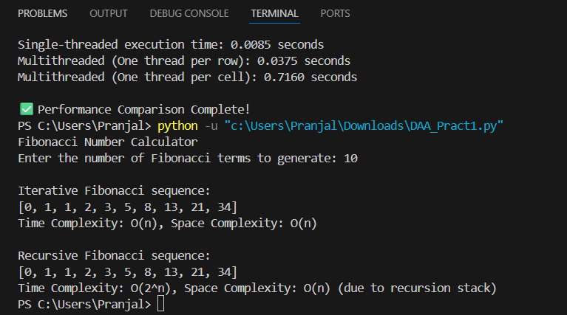
Output:-

